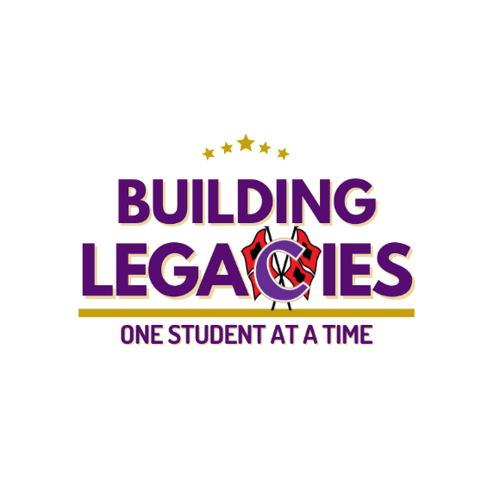**Cartersville High School**

**Course**: American Literature

**Instructor**: Mrs. Ginny Weaver, T. Bullock, E. Zaldivar

**Email**: [gweaver@cartersvilleschools.org](mailto:gweaver@cartersvilleschools.org)

**Room**: Humanities, Room H212

**Website**: <https://www.cartersvilleschools.org/domain/2017>

**Course Description**

American Literature utilizes the 11th Grade English Language Arts Georgia Standards of Excellence to guide the course’s curriculum map. The standards cover:

* reading informational and literary texts;
* writing argumentative, informational, and narrative texts;
* performing within various speaking and listening tasks;
* and demonstrating various thorough correct language approaches.

For the course’s learning objectives, students will learn, practice, and assess their knowledge with the standards (above) through different processes and subject matters demonstrating rigor; these processes and subject matters are intended to help prepare the students for their future post-secondary options. The curriculum depends heavily upon the access and use of technology inside and outside of the classroom; students need to secure access to a computer with a working printer. The school and local library allow such services. All students and parents should make a **daily connection** with **Schoology** an all-inclusive deposit of the class and curriculum’s content. Schoology’s constant access will help to supplement all aspects of American Literature but should not be depended upon exclusively. **The greatest tool for success in American Literature is a prepared, focused, receptive, and working student.**

The course is taught bell to bell, which means the students will always have some academic focus within the class. Class will begin with bell work (a class warm-up assignment), opening (introduction and initial formative development of the curriculum’s current focus), work period (formative facilitation and development of the curriculum’s current focus through application), and closing (an opportunity for questions, redirection, and formative assessments). Students should seek to learn the intricacies of this process to benefit learning.

**Extended Texts and Course Organization**

This year, our class will readthe extended text*, The Crucible* by Arthur Miller as well as supplemental texts. These works/novels have been approved by the district and support the curriculum. If you wish for your student to have an alternate assignment, please contact me at [gweaver@cartersvilleschools.org](mailto:gweaver@cartersvilleschools.org).

Course texts are organized into thematic units of study. Ongoing formative assessments occur in each unit to ensure students are progressing toward mastery of the unit objectives. A minimum of one summative assessment is embedded within each unit of study.

**Curriculum Map and Assignments**

**Reading**

This course will focus on readings related to real-life topics and types of writing. The readings will include articles, essays, editorials, speeches, videos, poems, and literature, from classical to contemporary.

**Writing**

You will practice the following types of writing this year:

* Argumentative
* Informational/Explanatory
* Research
* Routine Writing: notes, summaries, process journals, short responses to/analysis of texts

**Speaking and Listening**

You will practice the following types of oral presentations this year:

* Fluency Recitation
* Narrative, Informational, and Argumentative Recitation
* Personal Think-Aloud Responses
* Group Discussions
* Group Presentations

**Concepts, Skills, and Policies**

This course offers discussion and practice of concepts and skills necessary to college and career, skills that you will use every day, as well as critical thinking and writing; for example:

* Developing and focusing ideas
* Organizing, revising, and editing strategies
* Grammar and usage, style, mechanics, punctuation
* Evaluating writing
* Improving speech within a variety of processes
* Research
* Vocabulary

**Specific Expectations**

* Uphold the ***Canes Code*** including the procedures and policies detailed in the *CHS Student Handbook*.

C: Commit to Excellence

O: Own your Behavior

D: Demonstrate Respect

E: Exhibit a Positive Attitude

* Be prepared—bring all materials to class.
* Display respect and courtesy toward all.
* Take very good care of materials, supplies, equipment, and furniture in this classroom.

**Grading**

The semester grades are made up of a combination of Formative (40%) and Summative (60%) assessments.

* At the end of a semester course, the Final Course Average is calculated with 80% (semester grade) and the Final Exam, 20%.

**American Literature does require a Georgia Milestones End of Course exam.**

**English Department Late Policy**

For any formative or summative assignments not submitted by the deadline established by the teacher, students have three additional school days to turn in the work for late credit. Each day late results in a ten percent deduction from the student's calculated grade. After three days, the student may not earn a score higher than 50 on the late assessment. The deadlines for submission of any outstanding assessments are **December 13, 2023**, and **May 8, 2024**, for semester 1 and semester 2, respectively.

**Grade Reporting**

Parents and students are encouraged to utilize Infinite Campus to monitor ongoing academic progress and attendance. If you (student or parent) have not obtained your credentials for this tool, please contact the CHS front office staff at (770) 382-3200 for assistance.

Assessment grades are recorded in Infinite Campus at least once per week.

**Academic Honesty:** Plagiarism is a serious offense! CHS Plagiarism Statement:

Plagiarism is the act of taking someone else’s words or ideas and using them as your own, intentionally or carelessly. Generally, if the information or idea comes from an outside source and is not common knowledge, the source must be cited in the body of the paper along with bibliographic information. Whether the information is paraphrased, summarized, or quoted, you must have source documentation. In addition, you must use quotation marks when taking an author’s phrases or statements directly from the text.

Handing in work written by another student, copied from another student, or found on the Internet is also considered plagiarism. All forms of plagiarism, regardless of intent, will result in a zero for the assignment, as well as parent and administrative contact. Please refer to the CHS student handbook regarding this policy.

**Classroom Expectations**

**Leaving the Classroom**

Students are expected to remain in the classroom. To accommodate occasional urgent needs, each student will be given **five** restroom passes per semester. These passes will not be replaced if misplaced. If additional restroom passes are required, they will be allowed; however, students will serve 15-minutes of teacher detention for each extra pass. This time will allow for classroom instruction/student work time based upon what was occurring in the classroom while the student was away.

Should a student have a medical condition necessitating unlimited access to the restroom, he/she should communicate this need to me at the beginning of the school year.

**Classwork and Homework**

* **We will try to do much of our work in class. If you do not finish in class, however, the work is assigned as homework.** You must continue working from home on your digital learning days; due dates will not change because of our hybrid schedule.
* **Make up work:** all assignments are due on the date specified in the course schedule, either in-class or through Schoology, depending on the assignment. If you are absent, it is YOUR responsibility to see me if you wish to discuss your work (before or after school, not during class). You **cannot** make up **unexcused** absence work.

**Tools for Communication**

Students should contact the teacher immediately with any issues. In most cases, the teacher will respond to the student within twenty-four hours. For parent contacts, the teacher will respond within forty-eight hours.

Students should use Schoology’s messaging system to contact the teacher.

Teacher-to-parent communication will occur using Blackboard, the school system’s messaging system. Blackboard connects to the phone numbers and email addresses that you have within PowerSchool. Please make sure you and your student’s PowerSchool information is updated and accurate to ensure the most effective form of communication for American Literature. If you have any concerns regarding your PowerSchool information, contact the High School’s front office (770-382-3200).

**Electronic Devices**

As a rule, all electronic device use is not allowed in the class; **this includes smart watches, cell phones, cameras, headphones, or any other similar device.** If brought to class, your electronic device should be on **“do not disturb”** and should be out of the teacher’s sight, placed in the cell phone holder provided in the classroom. If the teacher slightly questions a conflict with this rule for electronic devices, the electronic device will be confiscated and processed according to the Cartersville High School’s electronic device infraction policy.

**Late to Class (Tardy Policy)**

The school policy for a tardy is strictly enforced. If the student is not through the doorway when the tardy bell rings, he or she will retrieve a tardy slip from the office. Remember, 3 unexcused tardies result in 1 unexcused absence and a student may not exempt the exam with an unexcused absence.

**Materials**

You should come to class prepared with the proper materials:

* Purple Folder (provided)
* Notebook paper
* Pen/pencil
* Cartersville City Schools App

*You will have a purple folder in the classroom and it should remain in the classroom, unless permission is granted.

|  |  |
| --- | --- |
| **Class Dates** | **Course Outline** |
| First Day | Introductions, syllabus, general orientation. |
| August | **“Introduction to American Literature Time Periods”** |
| September | **“Birth of the United States”**  Writing Focus: Narrative |
| October | **“Awakening of the United States” & “American Renaissance”**  Writing Focus: Argumentative |
| November | **“Realism”**  Writing Focus: Argumentative |
| November | **“Modernism”**  Writing Focus: Informational/Explanatory |
| December | **“Contemporary”**  Writing Focus: Informational/Explanatory |
| Last Week of Semester | **American Literature Georgia Milestones End of Course Exam** |